**Name :Esha Shahzad**

**Sap#5593**

**COAL LAB#5**

**Task#1:** Run given sample programs and analyze the output.

org 100h

.model small

.stack 100h

.data

.code

main Proc

mov ah,01

int 21h

mov bx,ax

mov dl,45

mov ah,02

int 21h

mov ah,01

int 21h

mov cx,ax

mov dl,61

mov ah,02

int 21h

sub bx,cx

add bx, 30h

mov dx,bx

mov ah,02

int 21h

mov ah,4ch

int 21h

main endp

end main

**Output:**

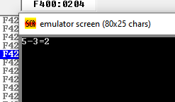

**Task#2Write a program to find the sum of three single-digit numbers entered by user;**

.model small

.stack 100h

.data

.code

main Proc

mov ah,01

int 21h

mov cx,ax

mov dl, '+'

mov ah,02

int 21h

mov ah,01

int 21h

mov bx,ax

add cx,bx

sub cx, 30h

mov dx,cx

mov dl, '+'

mov ah,02

int 21h

mov ah,01

int 21h

mov bx,ax

mov dl, '='

mov ah,02

int 21h

add cx,bx

sub cx,30h

mov dx,cx

mov ah,02

int 21h

mov ah,4ch

int 21h

main endp

end main

**OUTPUT:**

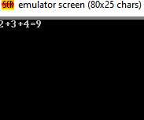

**Task#3:** **Write a program to use the SCAN_NUM to input prompt for values for three variables x, y and z and the PRINT_NUM to display an appropriate label and value of the expression x – y + z – 1.**

.model small

.stack 100h

.data

.code

main Proc

mov ah,01

int 21h

mov cx,ax

mov dl,45

mov ah,02

int 21h

mov ah,01

int 21h

mov bx,ax

sub cx,bx

add cx,48

mov dx,cx

mov dl,43

mov ah,02

int 21h

mov ah,01

int 21h

mov bx,ax

add bx,cx

sub bx,48

mov dx,bx

mov dl,43

mov ah,02

int 21h

mov dl,'1'

mov ah,02

int 21h

mov dl,61

mov ah,02

int 21h

add bx,1

mov dx,bx

mov ah,02

int 21h

mov ah,4ch

int 21h

main endp

end main

**Output:**

